**Ticket booking on Cleartrip:**

1. Open <http://www.Cleartrip.com>website.
2. A pop-up window opens, enter your mobile number.

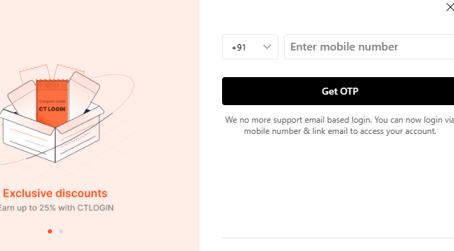

1. Enter OTP number sent to your registered mobile number.

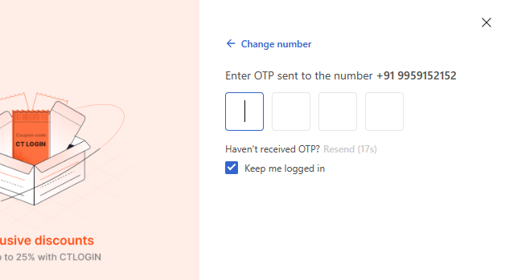

1. Enter your email id, click Next or Skip (if you don’t want to receive notifications).
2. It navigates to main page, on left pane, select mode of transport that is flight or bus.

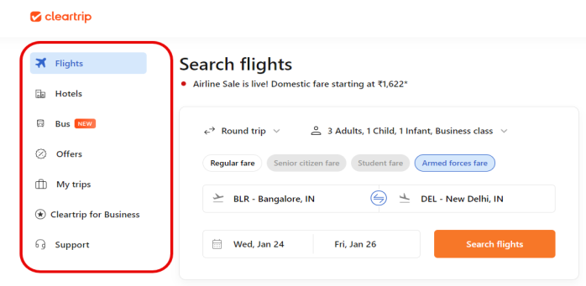

1. Select Flights if you want to travel by flight.
2. Select One way or Round trip (traveling from a starting point to a destination and then returning back to starting point).

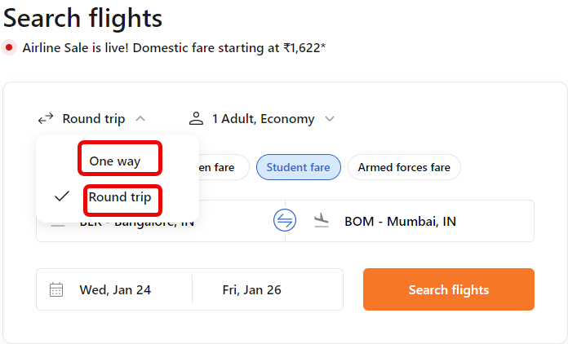

1. Select Economy**/**Business class/First class/Premium economy, accordingly ticket prices vary.
2. Select Regular fare, if you are traveling with Adults, Children, Infants.

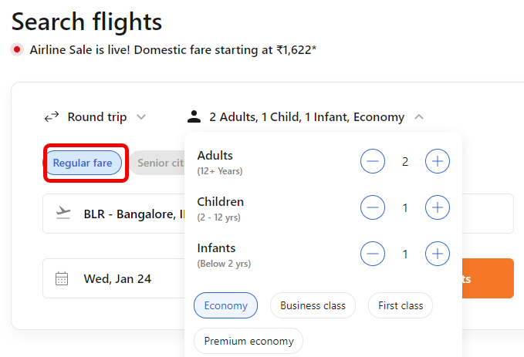

1. Select Senior citizen fare, if your age is above 60 years. You can add only adults.

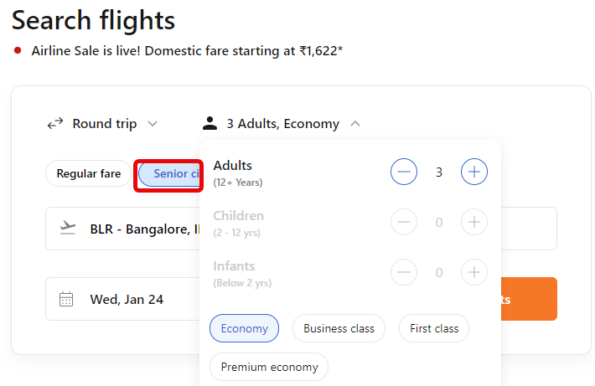

1. Select Student fare if you are above 12 years with valid id. You can add only adults.

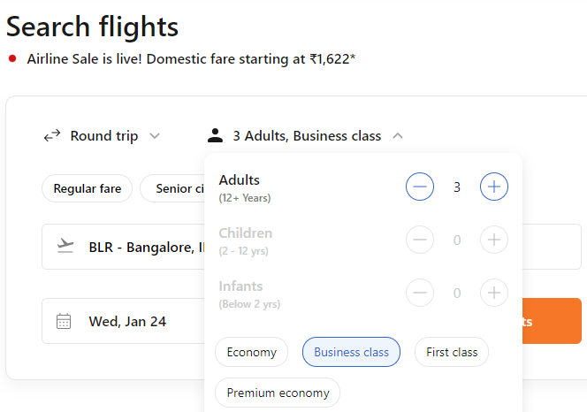

1. Select Armed forces fare if you are serving/retired armed forces personnel and also dependents can avail this offer. You can add adults, children and infants.

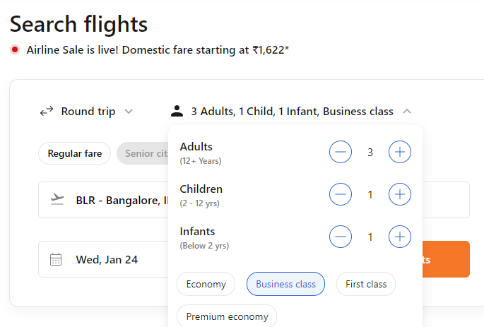

1. Select Where from, drop down list appears to select jumping-off point in your city.

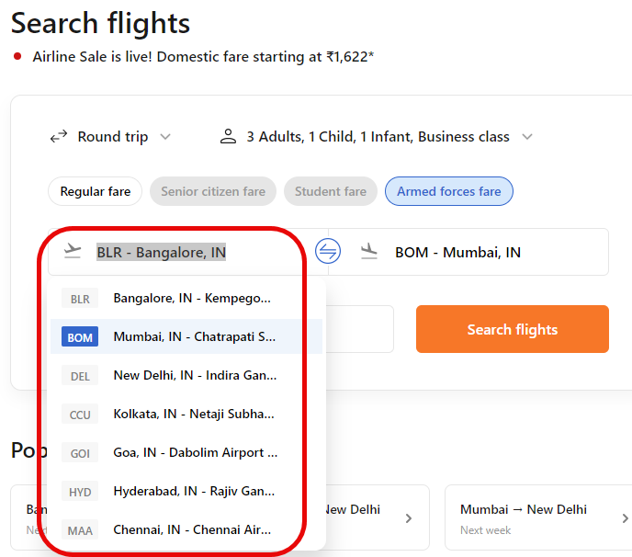

1. Select Where to, drop down list appears to select the destination place.

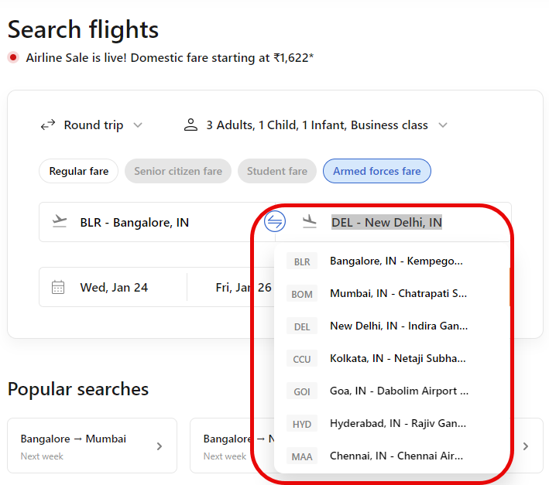

1. Select the date you want to travel.

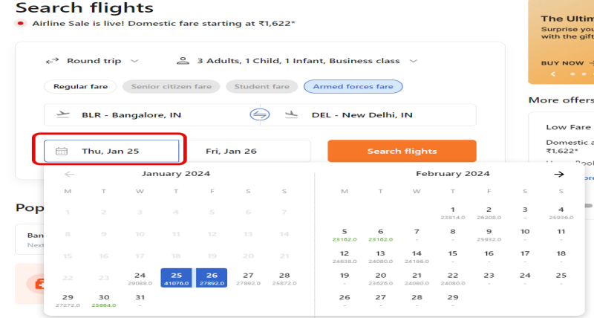

1. If it is a round trip, Select the date when you want to travel back.

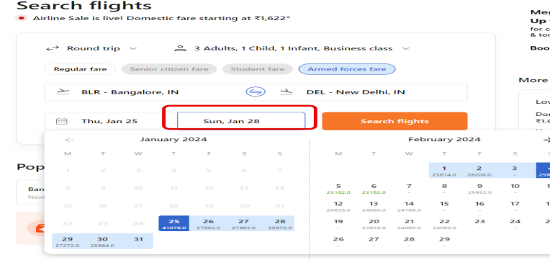

1. Now, click Search flights.
2. The next page shows the list of flights available.

* On the top, details of your journey are displayed.
* On the left pane, select stops, departure time from jumping-off point, and departure time from destination.
* Also select one way price, airlines, trip duration, and layover duration.
* On the right pane, click Book now.

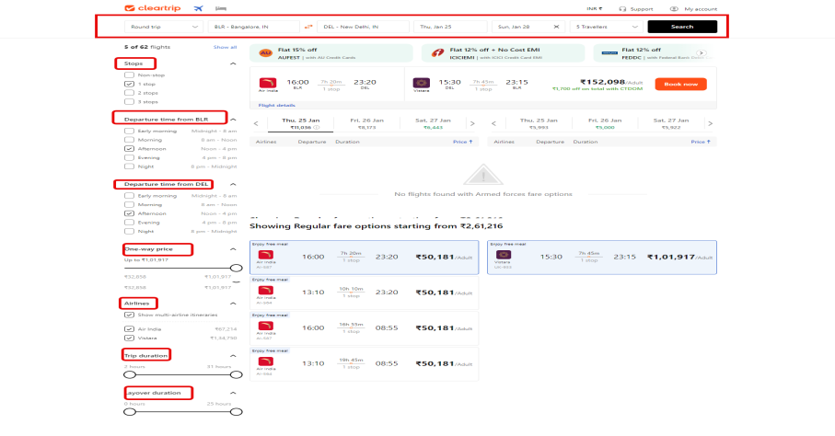

1. The next page displays review itinerary.

* Check cancellation policy and date change policy, in case you want to cancel the ticket or change the dates respectively.
* Check total price on right pane.
* Click Continue.

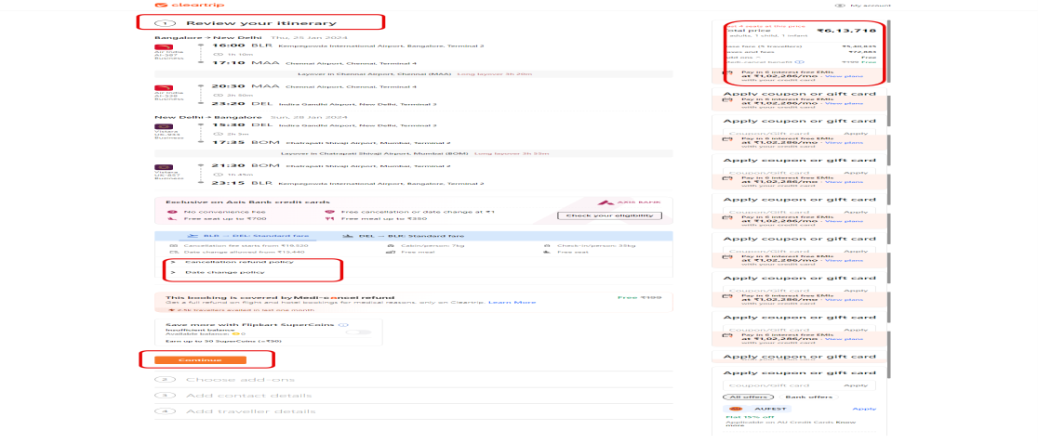

1. In the next page, add your mobile number and email id. Click Continue.
2. Select the mode of payment. Click Continue.
3. Online booking details are sent to your registered mobile number and email id. Click Logout.